**Practical Bioinformatics**

Wagner Section

**Exercise Block 2. Analyzing simple biological networks**

*Metabolic networks* – We will use the following two metabolic networks in this section

1. glycolysis.xml - This metabolic network consists of reactions involved in the glycolysis pathway. The objective function is the maximization of ATP production (abbreviated as atp in the metabolic model). Figure 2 below is a pictorial representation of the network.

2. e_coli_core.xml - This metabolism contains what is called the core *E. coli* metabolic network, as proposed by the laboratory of Bernhard Palsson (<http://gcrg.ucsd.edu/Downloads/EcoliCore>). Files Ecoli_core_figure.pdf and Ecoli_core_figure.jpg are added to this folder as a visual representation of the core *E. coli* model.

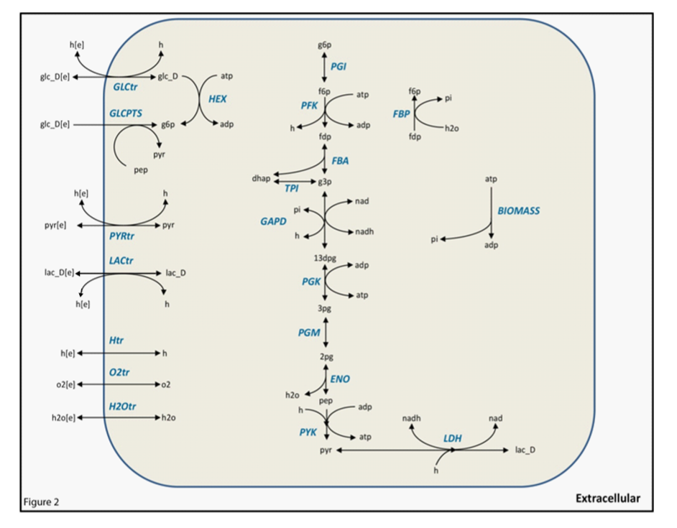

**Exercise 2.1. Load the glycolysis model into python. How many metabolites and reactions does it include?**

Note that this model uses short-hand reaction identifiers (ids) that are not the same as a reaction’s name.

You can read a sbml file in the following way:

from cobra.io import read_sbml_model

model = read_sbml_model('model_name.xml')

Write a script that lists all reactions and their associated information. It should look something like this:

name : id : lb : ub

GLCtr : R1 : glc_D_e + h_e <=> glc_D + h : -1000.0 : 1000.0

GLCPTS : R2 : glc_D_e + pep --> g6p + pyr : 0.0 : 1000.0

HEX : R3 : atp + glc_D <=> adp + g6p : -1000.0 : 1000.0

How many metabolites and reactions does the model have? Provide a list of the metabolites and reactions.

Once you have identified each reaction, perform FBA to maximize atp production. Provide a list of all active reactions. How many are there?

**Exercise 2.2. GLCPTS (glucose phosphotransferase system) is a reaction that imports glucose into the cell. Use figure 2 to answer if GLCPTS is an essential or a nonessential reaction? Why or why not? Then use COBRApy to check your answer.**

(See exercise 1.6 for a description of the command needed to perform single reaction deletions.)

**Exercise 2.3. Use figure 2 shown above and the model glycolysis.xml to identify the role of the reaction catalyzed by lactate dehydrogenase (LDH in the model), beyond its enzymatic function.**

Hint: Is LDH an essential reaction? Why or why not? Which cofactors are involved in the LDH reaction? How many other reactions use these cofactors? After performing FBA try the command model.metabolites.nadh.summary()*,* which may help you answer the question.

**Exercise 2.4.This exercise regards the extent to which a metabolic network can be "flexible", i.e., achieve a given objective in different ways. This question is difficult to answer comprehensively, but Flux Variability Analysis (FVA) can provide some insights. FVA computes the minimum and maximum value ofthe flux through a reaction, while keeping a given objective, such as biomass synthesis, unchanged. That is, FVA provides a measure of a reaction’s “flexibility”. A simple measure of a network’s flexibility is provided by the sum of the flexibilities of all reactions in the network.**

The following command will perform FVA for all reactions in a model when the biomass growth flux is constraint to its maximum value.

fva_result = cobra.flux_analysis.flux_variability_analysis(model, model.reactions[:], fraction_of_optimum=1)

The option ‘fraction_of_optimum=1’ means that FVA is performed subject to the constraint that the objective function (e.g., maximal biomass growth) attains the maximal (optimal) value. The constraint set to the objective function can be diminished by replacing fraction_of_optimum to any number in the range 0 to 1.

Calculate the network’s flexibility when constraining biomass growth to different fractions of the optimum. Does flexibility change when relaxing the constraint of optimal growth? If so, why?

**Exercise 2.5. In this and in the following exerciseswe will work with the core metabolism of *E. coli.* Before performingany calculations, it is always good to take a look at the model. Open the model and listthe number of metabolites, genes and reactions. How many external reactions does this model include? Which metabolites can be imported into the cell?**

To find the external reactions it may be useful to know that in this model all reaction ids start with 'EX_'. For example, the identifier for the external reaction of oxygen is EX_o2_e. Also, keep in mind that if a metabolite is taken up by the cell, it's associated external reaction will show a negative flux.

**Exercise 2.6. Compute the biomass production of the network for different uptake rates of glucose. Plot biomass against glucose uptake rates. Explain the relationship between the two quantitiesthat you observe.**

An important concept for this section is that of a (growth-)limiting nutrient. A nutrient is limiting if a reduction in its uptake rate leads to a reduction in growth.

Start by computing FBA with the default value (10 mmol/gDW/hr of glucose).

Take a look at the results. Then compute the rates withdifferent glucose uptake values ranging from 0 to 50.

To perform this task, you will need to change the flux boundaries. This be done with:

model.reactions.get_by_id("REACTION ID").lower_bound = ANY VALUE.

model.reactions.get_by_id("REACTION ID").upper_bound = ANY VALUE.

Make a plot to visualize your results. Describewhat you see. Is glucose growth-limiting over the entire concentration range? If not, which other nutrient(s) might be growth-limiting?

Here you have an example of how to plot in python using matplotlib:

import matplotlib.pyplot as plt

import numpy as np

x = np.linspace(0,20,21)

y = x**2

plt.plot(x,y,marker='o',linestyle='none')

plt.xlabel('here is x')

plt.ylabel('here is y')

plt.title('A simple plot')

plt.show()

**Exercise 2.7. Let's take a deeper look to understand what happens when the glucose uptake changes. Write ascript that will perform FBA for different glucose uptake values between 0 and 50 mmol/gDW/hr. Store the flux value of the external reactions with ids: EX_o2_e, EX_co2_e, EX_ac_e and EX_etoh_e. Plot these fluxes against the glucose uptake rate and try to explain the pattern you observe.**

**Exercise 2.8. Are there any other metabolites that could be used ascarbon sources for the core metabolism of *E. coli*?**

Hint: For a metabolite to be a carbon source it must possess at least one carbon atom and has to be able to beimported into the cell. The later means that the metabolite has an associated external reaction.

Checking if a given metabolite possesses at least one carbon atom canbe a little more troublesome. Luckily, in this model the chemical formula of metabolites is included. Look at the example below:

In[1] model.metabolites.get_by_id('glc__D_e').formula

Out[1]: 'C6H12O6'

Since this model is small enough, you may print the formulas of all external metabolites to find the ones that fulfil the conditions for being a carbon source by hand. If you feel confident write a python script to do this automatically.

**Exercise 2.9. Compute the biomass growth rate for acetate as a carbon source with an acetate uptake flux of 10 mmol/gDW/hr. Is it different from the biomass growth rate on glucose with the same uptake rate? Why or why not?**